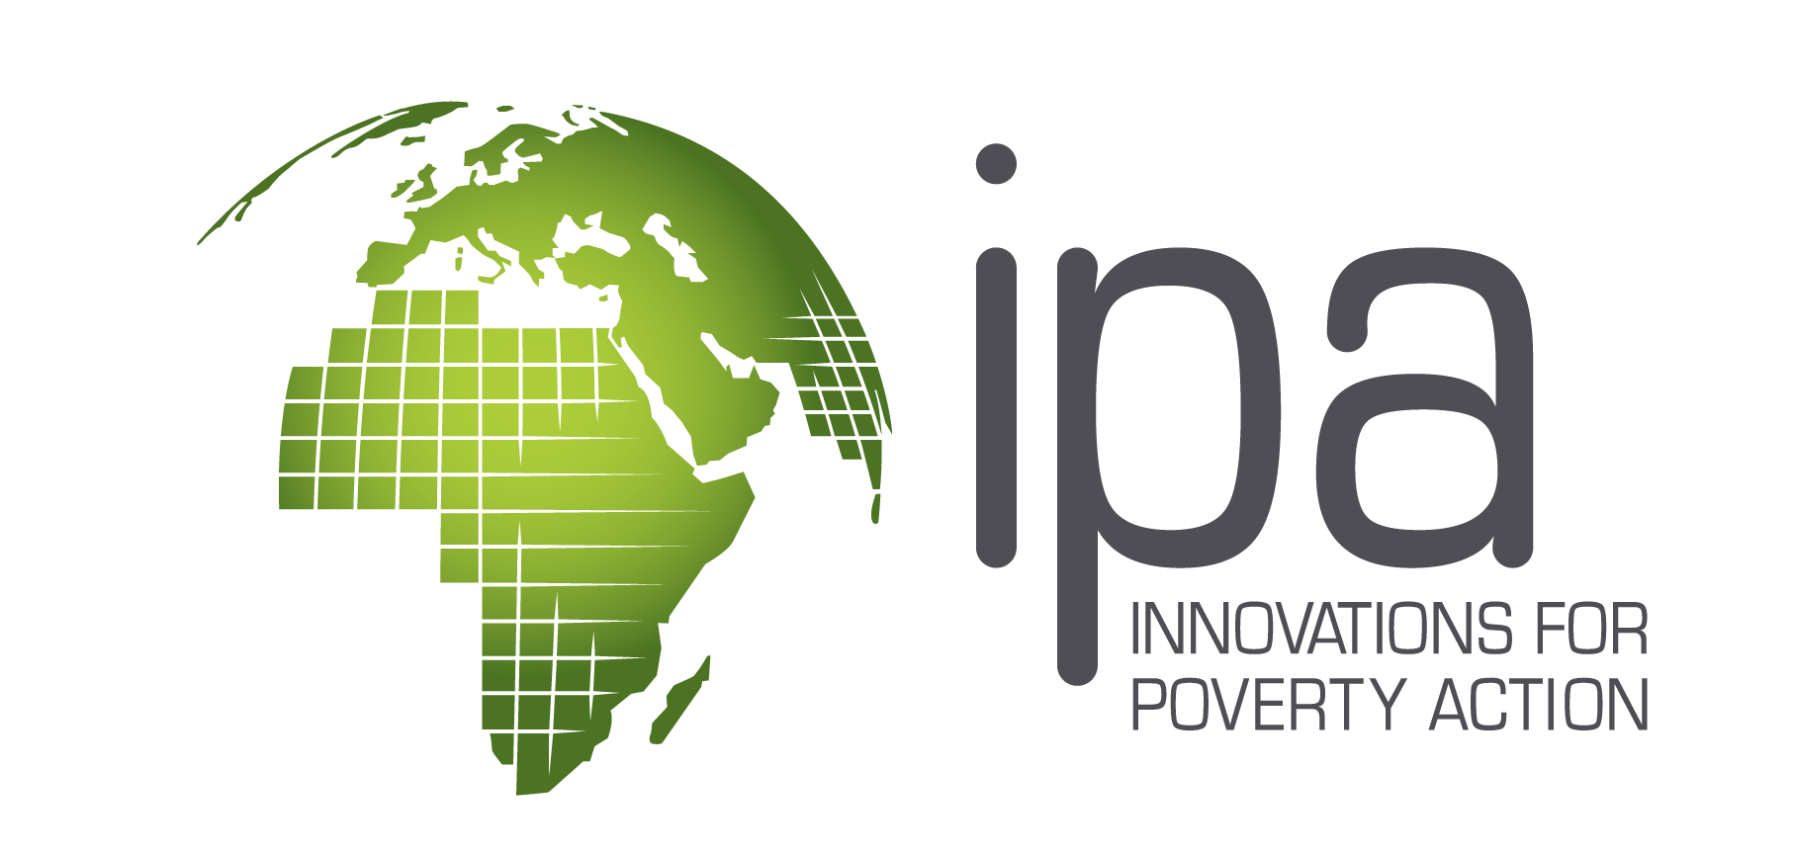
Consumer Protection Research INITIATIVE | RESEARCH Proposal

The Consumer Protection Research Fund is open to all academic researchers and accepts proposals for randomized evaluations in Bangladesh, Kenya, Nigeria and Uganda. Applicants are invited to consult the working paper “Consumer Protection for Financial Inclusion in Low and Middle Income Countries: Bridging Regulator and Academic Perspectives” to better understand the policy motivation and related research questions for this initiative.

Please fill in this form using Calibri 11 font, single spaced. Double-click on response boxes to mark your preference.

Title of Proposed Study Short but descriptive | Country / Countries

Project Overview

Abstract (max. 200 words) Briefly state the objectives of your research and summarize the research design.

Summary Timeline
Is the project ongoing? Has the intervention implementation or data collection begun? | Yes No
Project Start Date (DD / MM / YYYY)
Expected Project End Date (DD / MM / YYYY)

Funding Requested
Total Project Budget  * include activities that have been implemented or will be funded by other donors |  | USD
Funding requested from the Consumer Protection Research Initiative  * if the project does not have other donors/funding sources, enter the total budget proposed |  | USD

1. Research Team
Each application must be presented by a team consisting of one or more researchers involved in the design of the intervention and responsible for carrying out a rigorous evaluation of the program. At least one member of the research team must be affiliated with a research institution or a university and either hold a PhD or be a current PhD candidate in a relevant social science or engineering discipline such as economics, statistics, sociology, anthropology, psychology, public health, education, or computer science. They must demonstrate experience in field research and randomized control trials. Special consideration will be given to research teams with researchers from low and middle-income countries.

1.1a Primary Researcher
The primary researcher must be different from the lead contact of the practitioner organization.
First and Last Name |  | Country of Residence

Title & Affiliation
Research Experience | Has completed any Randomized Controlled Trials? Yes No  If yes, please provide a reference to one publication of an RCT.

1.1b Co-Researcher (if applicable)
First and Last Name |  | Country of Residence

Title & Affiliation
Research Experience | Has completed any Randomized Controlled Trials? Yes No  If yes, please provide a reference to one publication of an RCT.
If there are other researchers listed as co-applicants to this proposal, please copy the table above and provide details for each co-applicant.

1.2a Practitioner Organization (if applicable)

The term “practitioner organization” refers to the practitioner implementing the interventions that you propose to study. This organization is normally a financial service provider, a government agency, or a civil society organization.

Name of the Organization
Organization’s Website

Lead Contact Person
First and Last Name and Job Title

Country of Operation

Contact Email

Organization Website

1.2b Other Practitioner Organizations Involved in the Study (if applicable)

Please add the contact information of other practitioners that are carrying out interventions as part of your study design.
Organization  Name | Lead Contact Person at the Organization  First Name, Last Name, Job Title, and Email | Website

2. Research Narrative
The recommended length of the narrative is 5-6 pages (single-spaced, Calibri, 11-point font).

  - Context and target problem. Please describe the market and policy context that motivates this research. What is the target problem? What is the current state of knowledge in addressing the target problem? Please provide adequate references to prior academic work on this topic.

  - Research questions and academic contribution. Describe your research question(s) and study hypotheses. How will this study provide original insights on the target problem? How will this study contribute to the existing literature? Which specific mechanisms/barriers will the study test, and why are they relevant to the given context?

  - Relevance to consumer protection policy in target country and potential for policymaker engagement with research findings. Some of the main stakeholders in consumer protection are regulators, consumer protection agencies, and ministries. Please describe how your findings will be relevant to the interests of these policymakers and how you plan to engage them with the research findings.

  - Proposed intervention, target population and theory of change. Provide details on the intervention/treatment proposed and the target population. Please describe the theory of change that links the intervention/program with the anticipated outcomes in the target population. Why might we expect this intervention to be effective in addressing the target problem? Provide detailed information about the proposed intervention, including information in support of program feasibility; risks to the successful and timely roll-out of the program at scale; and data on uptake and usage from any ongoing or completed pilots. If a pilot has not been conducted yet, provide information on the timeline for any future piloting or why a pilot is not necessary.

  - Study location and partner organization. Describe the study location and the partner organization(s) carrying out the intervention. What is the status of your relationship with the partner organization(s)? Has the research team already agreed on roles and responsibilities to ensure proper adherence to research design?

  - Study design. Provide a detailed description of your study design (please include a table or chart). Provide details on your sampling frame, unit of randomization, and randomization strategy. Please include power calculations and the expected effect sizes to show how your study will be adequately powered to reliably detect the expected change in outcomes.

  - Data collection and analysis. Specify target outcomes, data collection and data analysis plans clearly. For example, if applicable, indicate how you plan to use administrative data from the practitioner organization alongside surveys and interviews.

  - Potential threats to validity . Briefly present the potential biases and threats to the internal validity of your study. How do you expect to limit such risks or correct for them?

  - Study implementation and project timeline. Detail the activities that you will carry out in your study, including the roll-out of the intervention and your data collection procedures. You should include a table that lists the timeline for the major activities involved in the project. Please also describe the roles and responsibilities of the members of the research team.

  - Plans for results dissemination, opportunities for replication or scale-up. Briefly describe how you intend to disseminate the results from your study, including in partnership with IPA’s Consumer Protection Initiative. If appropriate, describe the scope for the study to be replicated in other contexts or for the intervention to be scaled up if the present study demonstrates significant impacts from the intervention.

  - Cost-effectiveness analysis. Please describe whether it is suitable for your project to include a cost-effectiveness analysis.

3. Project Milestones
Please list each key milestone for the project (e.g. baseline survey design, baseline survey implementation, baseline data analysis, etc.). Normally we would expect each project to list 8-12 milestones. Add lines as needed.

# | Milestone | Target  Start Date | Target  End Date
1.
2.
3.
4.
5.
6.
7.
8.
9.
10.
11.
12.

4. Budget Narrative
Prepare a short (up to one page) narrative discussing your budget estimates and assumptions. For proposals requesting partial funding, make sure to include other funding sources, amounts, and your reasons for seeking supplementary funds.

Budgets should not exceed $300,000. Indirect costs may not exceed 15% of the funding request.

In addition to the budget narrative above, please use the provided Excel file template to prepare your budget. All funding is for research costs. Implementation costs for the program are expected to be covered by other sources. Any exceptions should be adequately justified in the budget narrative and will be considered on a case-by-case basis by the selection committee. In general, no funding will be provided for the salary or time of the researchers. In certain cases, adequately motivated funding for the salaries and/or time of researchers in low- and middle-income countries may be considered on a case-by-case basis by the selection committee.

5. Letter of Support from the Practitioner Organization
If applicable, please attach a signed letter of support from the partner organization (i.e., the organization implementing the intervention being evaluated) that confirms their participation in the proposed study and contains their endorsement of your research plan.

6. Letter of Support from the Research Implementing Organization
Projects are encouraged but not required to partner with the local IPA Country Office, as these offices have the experience and long-term presence to ensure that projects meet excellent research quality standards, maintain strong partner relationships, and that the study is well integrated with the work of the Consumer Protection Research Initiative and IPA, as a whole. Where applicable, please contact the relevant Country Representative (listed below) as well as Rafe Mazer (Project Director, Consumer Protection) as soon as possible to discuss and prepare your proposal.

• Bangladesh: Mohammad Ashraful (Ashraf) Haque, mahaque@poverty-action.org
• Kenya: Phebeans Oriaro Weya, poweya@poverty-action.org
• Nigeria: Emeka Eluemenour, celuemunour@poverty-action.org
• Uganda: Carin Mirowitz, cmirowitz@poverty-action.org

Where IPA offices are engaged in the proposal, budgets must be approved by the corresponding IPA country office before submission. IPA offices can support applicants in research design, engagement with potential partner organizations, and preparation of budget and proposal materials.

6. Proposal Checklist
Proposal File
Rename: CP_Proposal_[ResearcherLastName]_[PractionerOrg]_[Country]_2021.docx
Save the proposal (Sections 1 to 4, including this checklist) as a single Microsoft Word file.
1. Research Team
2. Research Narrative

3. Milestones

4. Budget narrative

Review the Terms and Conditions presented on the next page

Attachments

5. Budget
Rename: CP_Budget_[ResearcherLastName]_[PractitionerOrg]_[Country]_2021.xlsx

6. Signed Letter of Support from Practitioner Organization (if applicable)

Rename: CP_PracLetterSupport_[ResLastName]_[PractOrg]_[Country]_2021.pdf

7. Signed Letter of Support from Research Implementation Organization

Rename: CP_ResOrgLetterSupport_[ResLastName]_[PracOrg]_[Country]_2021.pdf

Submission deadline is February 26, 2021.

Please email your submission to financialinclusion@poverty-action.org.
The subject line of your email should read:
“CP Proposal 2021 [ResLastName] [PracOrg] [Country]”

CONSUMER PROTECTION RESEARCH INITIATIVE | GENERAL TERMS AND CONDITIONS
General Terms and Conditions
- This Request for Proposals is not and shall not be construed to be a contract, offer, or request for an offer. Those responding to this call receive no rights whatsoever as a result of their submissions. Innovations for Poverty Action (IPA) will not have any express or implied obligations or responsibilities to those who respond and will not otherwise be bound by any terms or conditions, except to the extent set forth in a definitive, final, written grant agreement duly executed by the recipient(s) and IPA. There is no commitment by IPA that such a final grant agreement will be executed, even if IPA enters into negotiations with an applicant, proposed recipient(s), or his or her institution.
- IPA in its sole and exclusive discretion may reject any or all proposals with or without notice or reasons, withdraw this call at any time before or after delivery of proposals, or if no proposal is accepted, abandon the call.
- IPA further reserves the right in its sole and exclusive discretion to waive irregularities or defects in any proposal, but in no event will IPA have any obligation to do so. Moreover, IPA will not be responsible for errors or omissions by anyone submitting a proposal, and IPA shall be the sole judge of the responsiveness, appropriateness and completeness of any and all proposals.
- IPA reserves the sole and exclusive right in its discretion to modify the timeline for decision-making or otherwise modify or amend this call as it deems appropriate.
- All responses to this call become the property of IPA. Regardless of any markings identifying the proposal or its content as proprietary or confidential, IPA reserves the right to disclose or use any information contained in the proposals and other presentations responsive to this call. The review board making funding decisions includes external academics and policymakers, who will receive a copy of the proposals.
- IPA is not responsible for and will not reimburse any costs incurred in submitting materials or information pursuant to this call or in otherwise responding to this call, including but not limited to evaluating, responding, providing follow-up, negotiating, and otherwise complying with it.
- Applicants agree to be bound by the terms of their proposal for at least ninety days from the date such proposals are due, and otherwise agree to negotiate in good faith any other terms for a definitive arrangement if selected by IPA to do so.
- Applicants certify that the work product they propose to create or use if they are a grant recipient will not infringe on or violate the intellectual property rights (including but not limited to trademarks, copyrights, patents, trade secrets, moral rights) or privacy rights of any person or entity. Applicants submitting proposals, materials, or information further certify that they have or will have such ownership or use rights in such work product sufficient to allow IPA to achieve its purposes as generally provided for in this call.
- Grant recipients agree that, if requested by IPA, they will provide additional information about any subcontractors, graduate students, research assistants, and other third parties engaged by the grant recipient to provide services. IPA reserves the right in good faith to approve any such persons in order to ensure consistency with IPA’s expectations of quality and character.
- Applicants are required to disclose to IPA all funders of their project. Depending on the co-funders, an applicant may be ineligible for funding from IPA under this call. Further information may be requested from IPA.
- IPA reserves the right to request additional information from applicants. Applicants agree to make themselves available for follow-up as reasonably requested by IPA.

Grant Terms and Conditions
If an applicant is awarded funding by IPA, the grant agreement may include clauses similar to the following, and the Grant Recipient must comply with them:

- Grant Recipients shall comply with Bill & Melinda Gates Foundation’s Global Access and Open Access policies, as updated from time to time. Current policies can be found here:
  - https://www.gatesfoundation.org/How-We-Work/General-Information/Global-Access-Statement
  - https://www.gatesfoundation.org/How-We-Work/General-Information/Open-Access-Policy
- Grant Recipients shall assign to IPA all copyright rights in all peer-reviewed articles that will be accepted for publication reporting original research supported in whole, or in part, by the funds provided under an award, including any underlying data (not including personally identifiable information) and materials, including primary data, associated metadata, original software, and any additional relevant materials necessary to understand, assess, and replicate the reported study findings. IPA represents copyright ownership is solely for the purpose of compliance as required by the Bill & Melinda Gates Foundation Open Access Policy.
- Grant Recipients shall automatically apply a creative commons license (CC BY 4.0 or equivalent) to all peer-reviewed articles that will be accepted for publication reporting original research supported in whole, or in part, by the funds provided under an award, and make public any underlying data (not including personally identifiable information) and materials, including primary data, associated metadata, original software, and any additional relevant materials necessary to understand, assess, and replicate the reported study findings.

This list is not exhaustive. The Grant Recipient may be required in the grant agreement to comply with other requirements from IPA and IPA’s prime donors.

Other leading digital financial services markets may be considered. Contact financialinclusion@poverty-action.org for more information.

