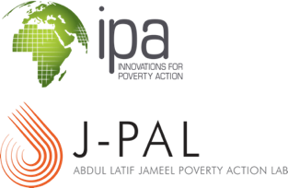
IPA/J-PAL Global Staff Training
Limuru, Kenya, March 14-18, 2016

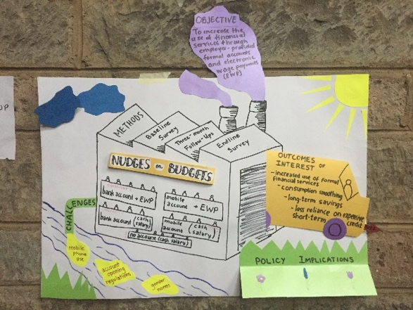

WHO
52 research staff from four organizations, including 39 IPA staff, 11 J-PAL staff, and 2 attendees from external organizations

WHAT
5 days of presentations, hands-on training, and engaging conversations
The winning poster from the project fair

WHY
Participants gain the theoretical and technical training needed to execute high-quality research studies in the field
- Quality control in the field
- Field team management
- Programming an electronic survey in SurveyCTO
- Stata programming
- Data security

TOPICS
- Research ethics
- Research design
- Randomization
- Power calculations
- Questionnaire design

“The project fair was so informative and interesting, an eye-opener to different project and research management styles.”

“I learned a lot about what quality controls and minimum must-dos I should be implementing in

Participants Rate Training*

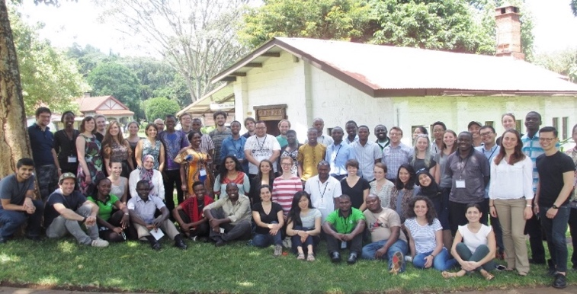
the field.”
“Thanks for the great week! Amazingly smooth.”

“Wonderful TA’s, and very useful presentations!”

 | IPA | J-PAL** | Overall
Pre-training communications and logistics support | 4.8 | 4.6 | 4.7
Training venue | 4.2 | 4.0 | 4.1
Training content | 4.2 | 3.6 | 4.0
Applicability of knowledge and skills to current work | 4.5 | 3.4 | 4.2

*Scored out of 5
**J-PAL was comprised mostly of policy staff, and the training was geared to a research audience

